Owner or operator:
(Name, Postal Address)
Distinguishing mark | IR | IN | FRC | FRCX | FNA | FNAX | FRC-FRC

Kind of vehicle |  | Semi Trailer |  | Trailer |  | Van
 |  | Truck |  | Swap Body |  | Container

General information:
Insulated body is manufactured in accordance with the Type test report No.:
Manufacturer of body |  |  | k- value |  | W/m²K
Manufacturer's mark / type |  |  | Built in (MM/YYYY)
Identification No. of body |  |  | Registration No.
Chassis No.

Dimensions: |  |  |  |  |  |  | Dimensions niche:
Inside (L x W x H [m]) |  | x |  | x |  |  | length x height [m] |  | x
Outside (L x W x H [m]) |  | x |  | x

Wall construction (to be stated only if different from the type tested unit [mm]):
 | Inside | Insulation | Density | Outside | Total
Roof
Side walls
Side door
Front
Rear
Floor
Partition wall transverse
Partition wall longitudinal

Equipment (must always be stated):
Rear door | 2-wings |  | 3-wings |  | 4-wings |  |  |  | other |  |  |  |  |  | strip curtain
 | rear door dimensions (width x height [m]) |  |  |  |  |  | x |  |  |  | lifting plattform |  | sealing up |  |  |  | yes |  | no
 | roller shutter | mark, type |  |  |  |  |  |  |  |  |  | Type test report No.

Side door | right | number |  |  | 1- wing | 2- wings | width | m | height | m |  | strip curtain
 | left | number |  |  | 1- wing | 2- wings | width | m | height | m |  | strip curtain

Other

Air flaps | front wall: | number |  | width | mm | height | mm
 | aft door: | number |  | width | mm | height | mm

 | number | recessed |  | number
Cargo securing rails / each side |  |  | Recesses in floor for  wheels
Cargo securing rails / roof
Cargo securing rails / floor |  |  | Lashing rings |  | recessed
Double deck rails |  |  | Kick plates |  | all around |  | height [mm]:
Meat hanging rails |  |  | Cabel duct |  | remarks:
Roof lamps |  |  | Partition wall longitudinal |  | fixed |  | moveble
Water drains |  |  | Partition wall transverse |  | fixed |  | moveble
Air duct system |  |  |  |  | foldable |  | removable
miscellaneous

Refrigeration or refrigeration-heating unit:
manufactured in accordance with the Type test report No.
Manufacturer |  |  |  | Type
Serial No |  |  |  | Refrigerant |  | Year built
For refrigerating units with multiple evaporators, type designation of evaporators to be provided additionally
with heating unit |  | at minimum outside temperature: |  | -10°C -20°C -30 °C -40°C

Temperature recorder:
manufactured in accordance with the Type test report No.
Manufacturer |  |  | Type |  |  |  | Serial No. |  | Year built

Only for multi-temperature refrigeration unit:

Configuration 1 |  | Configuration 2 |  | Configuration 3 |  | Configuration 4 |  | Configuration 5
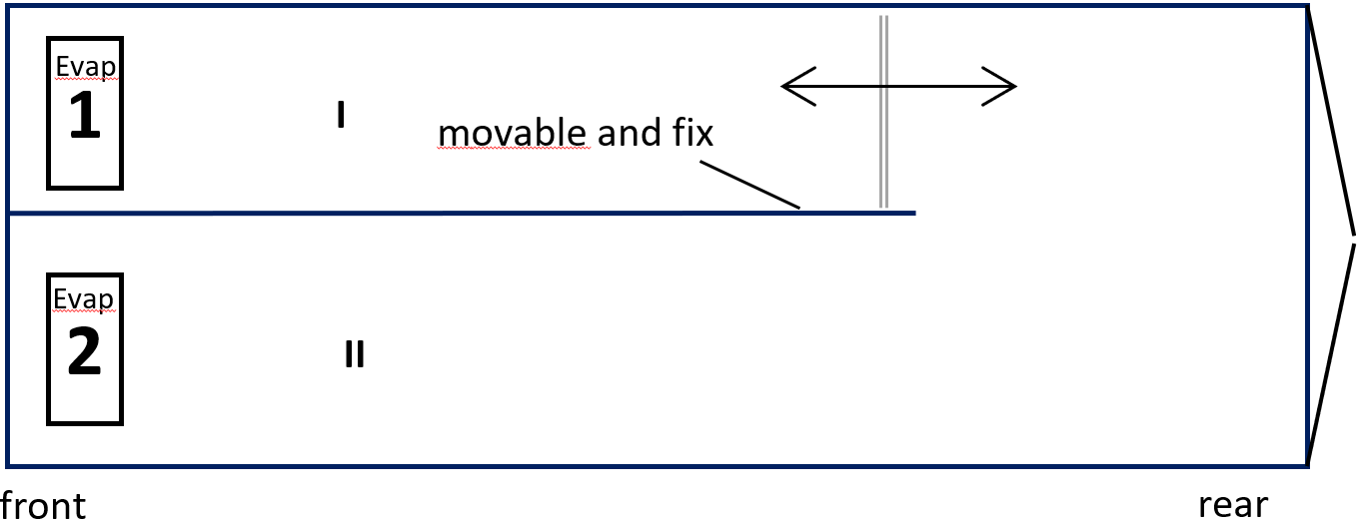 |  | 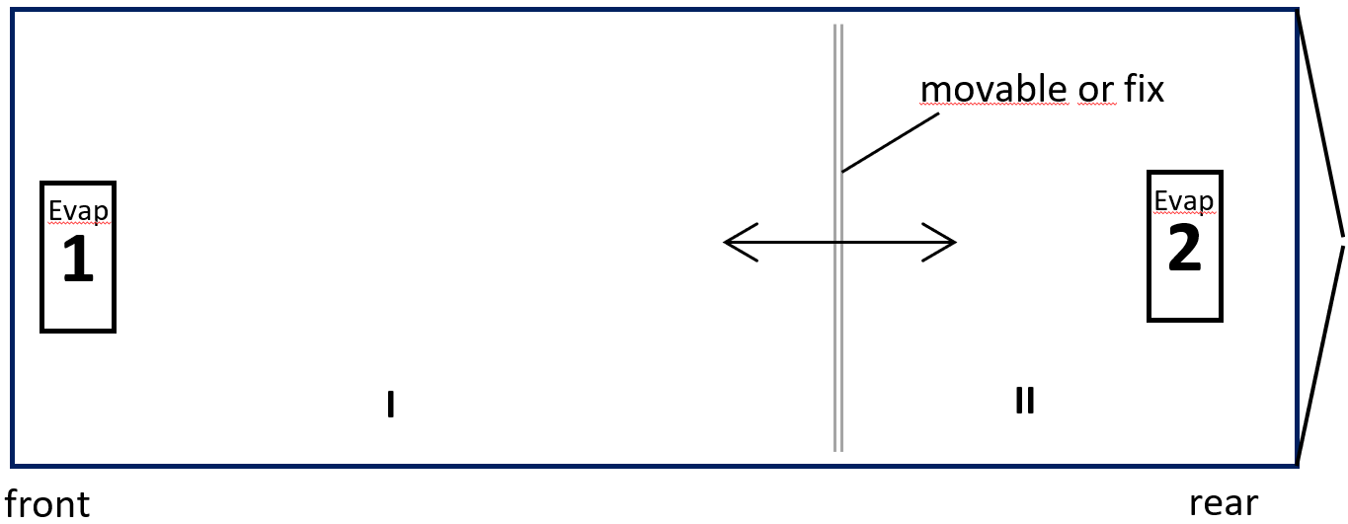 |  | 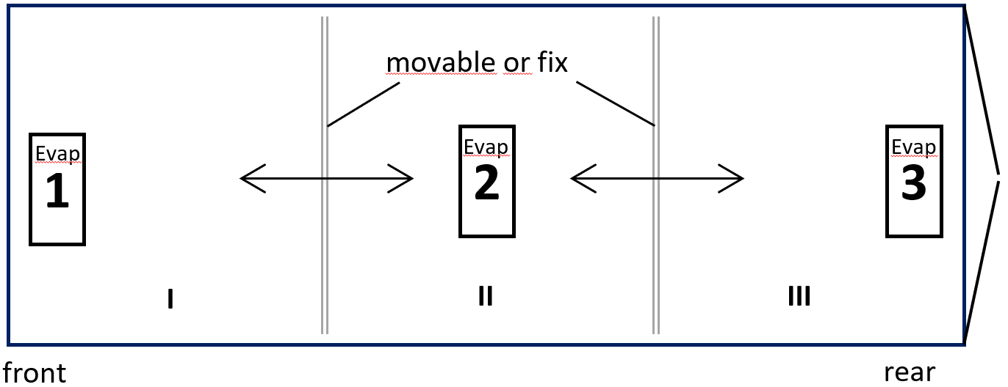 |  | 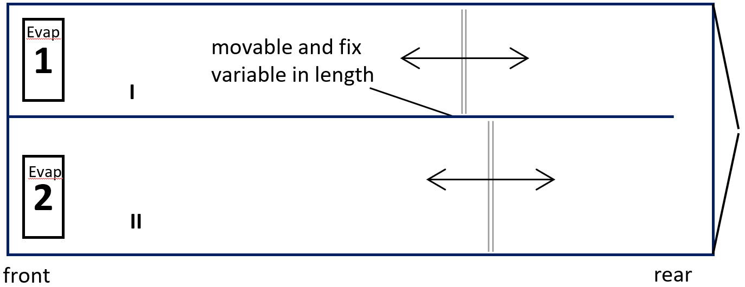 |  | 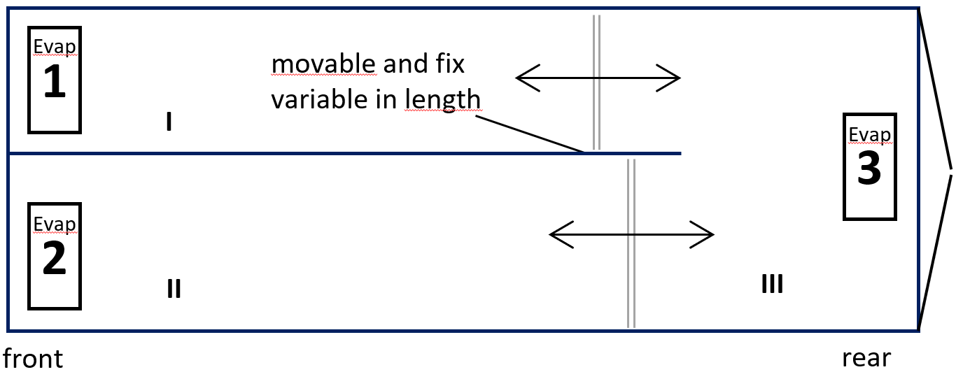
Configuration 6 |  | Configuration 7 |  | Configuration 8 |  | Configuration 9 |  | Configuration 10
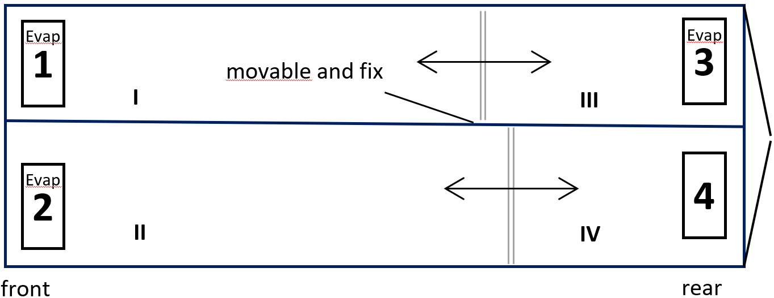 |  | 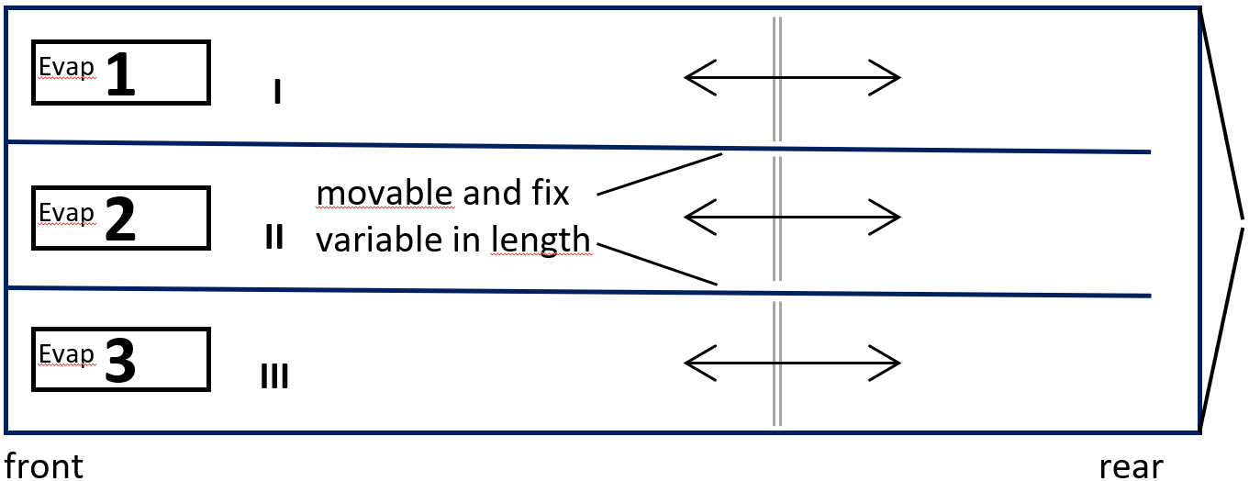 |  | 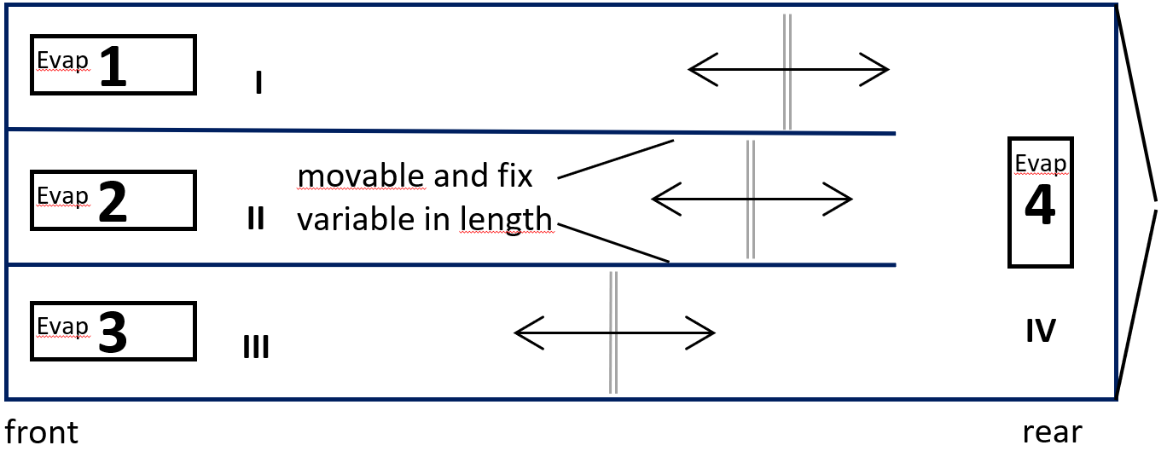 |  | 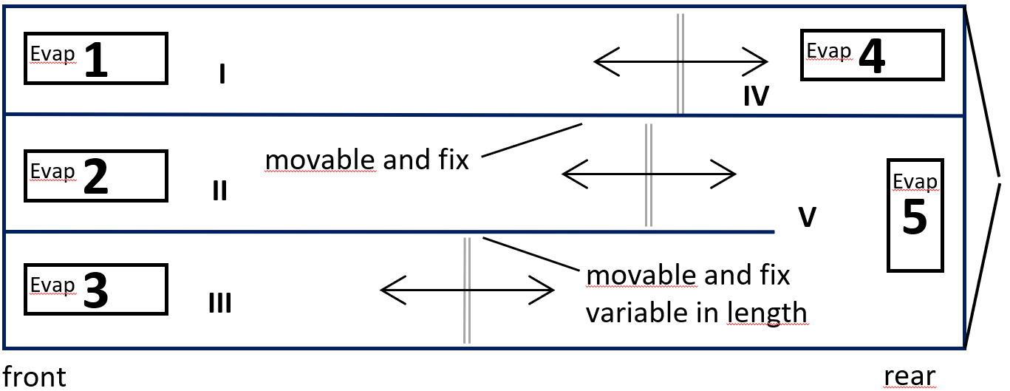 |  | 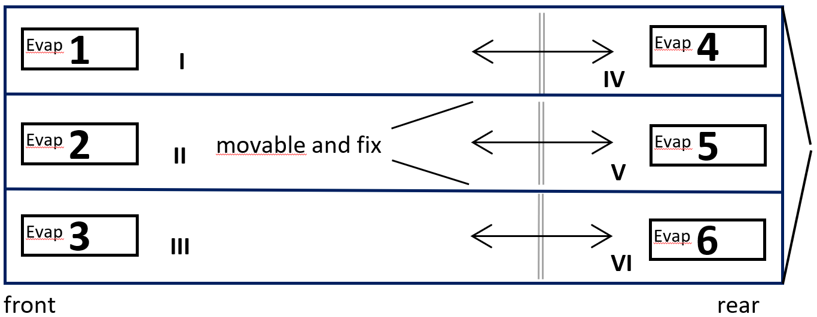

Evaporators: | 1 | 2 | 3 | 4 | 5 | 6
Type
Year of construction
Serial number

Data of internal bulkheads: | fixed | movable | Thickness [mm] | Length [m]
Longitudinal bulkead 1
Longitudinal bulkead 2
Transversal bulkhead 1
Transversal bulkhead 2
Transversal bulkhead 3
Querrtrennwand 1
Floor material of the body | ALU | GRP

Dimensions of compartments: | Inside [m] |  |  | Temp fix | Temperature each com-partment [°C] | Dry cargo |  | Lowest temperature according to ATP class allowed? | Temperature each com-partment [°C]
 | length min. | length max. | width |  |  | yes | no
Compartment I
Compartment II

Compartment III

Compartment IV

Compartment V
Querrtrennwand 1
Compartment VI

Remarks
General terms and conditions (GTC) read and accepted: DNV AGB

Date |  | Signature / Name of the Bodybuilder / Seal

